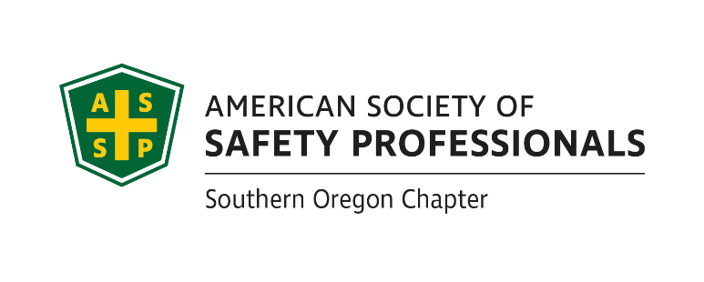

**2024 SOUTHERN OREGON**

**OCCUPATIONAL SAFETY & HEALTH CONFERENCE**

ASSP Award Application

***Safety Committee Recognition Award* In Honor of ~ Frank J. Bertak**

***& Best of the Best Safety Committee Award*** *_*

Section 1 Company Information

|  |  |  |  |  |
| --- | --- | --- | --- | --- |
| Company |  | Contact Person | |  |
| Division |  | Number of Employees | |  |
| Address |  | North American Industrial Classification System Code | |  |
| Phone |  | To Look Up NAICS Code: <https://www.naics.com/search/> | | |
| Email |  | | Fax |  |

Section 2 Injury and Illness Statistics

Provide Injury and Illness statistics for each year:

|  |  |  |  |
| --- | --- | --- | --- |
| Year | Total Number of Recordable | Number of regular and | Incident Rate: |
| Injuries & Illnesses on OSHA | overtime hours for all | Equals Number Recordable Injuries |
| 300 A Summary | employees for the year | Times 200,000 / Exposure hours |
| **2021** |  |  |  |
| **2022** |  |  |  |
| **2023** |  |  |  |

Section 3 Application Checklist

Complete form Sections 1 & 2 by typing in each shaded field and printing

Attach 1-page type written summary describing specific accomplishments

Attach Copy of a Safety committee agenda

Attach a list of current safety committee members

Attach copies of safety committee minutes from past 12 months (July 2023 through June 2024)

Attach quarterly inspection findings for this same period. (You must have at least one inspection for each quarter of the year.)

**Deadline:** Applications must be received by **August 30, 2024**

at SAIF-Medford Office at 990 N. Phoenix Rd. Ste. 101, Medford, OR 97504

(Questions: David Hanson [davhan@saif.com](mailto:davhan@saif.com) 541.857.4236,

**Incomplete Applications will not be accepted**

***Safety Committee Recognition Award***

**The Safety Committee Recognition Award** identifies safety committees, its members and activities that have made a significant contribution towards the company’s overall success. Businesses of qualifying safety committees must not have experienced a fatality or catastrophic accident in the past twelve months prior to the award presentation.

**Please submit a written summary** of not more than one (1) type written page of safety committee accomplishments, and also include:

⬩ Example of the safety committee agenda

⬩ A list of current members

⬩ Copies of safety committee minutes from the past 12 months (July 1, 2023 to

June 30, 2024)

⬩ Quarterly inspection findings from this same time period

Note: The safety committee minutes and inspection reports must meet the requirements of

OAR 437-001-0765 <http://www.orosha.org/pdf/rules/division_1/437-001-0765.pdf>

***Best of the Best Safety Committee Award***

One Safety Committee Recognition Award winner will be selected by the awards committee that demonstrates a superior safety committee effort during the award period. The Best of the Best Award will be given to the committee who outshines the rest in preventing harm to workers, promoting the cause of safety and health and making safety fun and engaging for all employees.

**If selected, a photo will be requested. Incomplete applications will not be accepted!**

*Awards Committee Notes:*________________________________________________________

****_____________________________________________________________________________________________________________________________________________________________________________________________________________________________________________________________________________________________________________________________________________________________________________________________________________________________________________________________________________________________________________________________________________________________________________________________________________________________________________________________________________________________________________________

**If you have questions or to arrange packet delivery:** Michael Hill [michil@saif.com](mailto:michil@saif.com) (541) 857-4229**,** Roy Harper [roy.harper@bbsi.com](mailto:roy.harper@bbsi.com) (541) 200-2199, or David Hanson [davhan@saif.com](mailto:davhan@saif.com) (541) 857-4236

**Deadline:** Applications must be received by **August 30, 2024** at SAIF, Medford Office at 990 N. Phoenix Rd. Ste. 101, Medford, OR

**Incomplete Applications will not be accepted**